UNITED STATES
SECURITIES AND EXCHANGE COMMISSION
WASHINGTON, D.C. 20549
___________________
FORM 8-K
___________________
CURRENT REPORT
Pursuant to Section 13 or 15(d) of the Securities Exchange Act of 1934
Date of Report (Date of earliest event reported): September 24, 2026
___________________
MONGODB, INC.
(Exact Name of Registrant as Specified in its Charter)
___________________
Delaware |  |  |  |  |  | 001-38240 |  |  | 26-1463205
(State or Other Jurisdiction  of Incorporation) |  |  |  |  |  | (Commission File Number) |  |  | (IRS Employer  Identification No.)
1633 Broadway, |  |  | 38th Floor
New York, |  |  | NY |  |  |  |  |  | 10019
(Address of Principal Executive Offices) |  |  |  |  |  |  |  |  | (Zip Code)
646-727-4092
(Registrant’s Telephone Number, Including Area Code)
Not Applicable
(Former Name or Former Address, if Changed Since Last Report)
___________________
Securities registered pursuant to Section 12(b) of the Exchange Act:
Title of each class |  |  |  |  |  | Trading Symbol(s) |  |  |  |  |  | Name of each exchange on which registered
Common Stock, par value $0.001 per share |  |  |  |  |  | MDB |  |  |  |  |  | The Nasdaq Stock Market LLC
 |  |  |  |  |  |  |  |  |  |  |  | (Nasdaq Global Market)
Check the appropriate box below if the Form 8-K filing is intended to simultaneously satisfy the filing obligation of the registrant under any of the following provisions (see General Instructions A.2. below):
☐ Written communications pursuant to Rule 425 under the Securities Act (17 CFR 230.425)
☐ Soliciting material pursuant to Rule 14a-12 under the Exchange Act (17 CFR 240.14a-12)
☐ Pre-commencement communications pursuant to Rule 14d-2(b) under the Exchange Act (17 CFR 240.14d-2(b))
☐ Pre-commencement communications pursuant to Rule 13e-4(c) under the Exchange Act (17 CFR 240.13e-4(c))
Indicate by check mark whether the registrant is an emerging growth company as defined in Rule 405 of the Securities Act of 1933 (§230.405 of this chapter) or Rule 12b-2 of the Securities Exchange Act of 1934 (§240.12b-2 of this chapter).
Emerging growth company ☐
If an emerging growth company, indicate by check mark if the registrant has elected not to use the extended transition period for complying with any new or revised financial accounting standards provided pursuant to Section 13(a) of the Exchange Act. ☐

Item 5.02 Departure of Directors or Certain Officers; Election of Directors; Appointment of Certain Officers; Compensatory Arrangements of Certain Officers.

Departure of President and Chief Executive Officer

On September 24, 2026, Chirantan (“CJ”) Desai, the President and Chief Executive Officer and principal executive officer under Section 16a-1(f) of the Securities Exchange Act of 1934, as amended (the “Exchange Act”) and a member of the Board of Directors of MongoDB, Inc. (the “Company”), notified the Company of his intent to resign from his positions with the Company, effective September 28, 2026. Mr. Desai’s decision to resign is not due to any disagreement with the Company or any matter relating to the Company's operations, policies or practices.

Appointment of Interim President and Chief Executive Officer

On September 26, 2026, the Board appointed Dev Ittycheria as the Company’s Interim President and Chief Executive Officer, effective September 28, 2026 to serve until a successor is duly elected and qualified unless sooner removed.

Mr. Ittycheria, age 59, previously served as our President and Chief Executive Officer from September 2014 to November 2025. He has been a member of our board of directors since September 2014. He will continue to serve as a member of the Board of Directors in addition to his role as Interim President and Chief Executive Officer. He currently also serves as a Partner and Senior Advisor at Sequoia Capital, a venture capital firm, a position he has held since September 2026. Prior to joining the Company, Mr. Ittycheria served as a Managing Director at OpenView Venture Partners, a venture capital firm, from October 2013 to September 2014. From February 2012 to June 2013, Mr. Ittycheria served as Venture Partner at Greylock Partners, a venture capital firm. From April 2008 to February 2010, Mr. Ittycheria served as President-Enterprise Management at BMC Software, Inc., a computer software company, which he joined in connection with its acquisition of BladeLogic, Inc., a computer software company that Mr. Ittycheria co-founded and for which he served as Chief Executive Officer. Mr. Ittycheria currently serves as lead independent director of the board of directors of Datadog, Inc., a public software company. Mr. Ittycheria previously served on the boards of directors of Bazaarvoice, Inc., a public software company from January 2010 to August 2014; Athenahealth, Inc., a public cloud-based services company from June 2010 to February 2019; AppDynamics, Inc., a private software company from March 2011 until its acquisition by Cisco Systems, Inc. in March 2017; DataRobot, Inc., a private software company from December 2021 to March 2024; and Altimeter Growth Corporation, a blank-check company formed by an affiliate of technology focused investment firm Altimeter Capital Management, LP from October 2020 to December 2021. Mr. Ittycheria received his B.S. in Electrical Engineering from Rutgers University.

Mr. Ittycheria does not have a family relationship with any of the other officers or directors of the Company. Mr. Ittycheria was not appointed pursuant to any arrangement or understanding between such individual and any other Person. There are no related party transactions between Mr. Ittycheria and the Company reportable under Item 404(a) of Regulation S-K.

The Advisory Agreement between Mr. Ittycheria and the Company, dated October 29, 2025, as previously disclosed in the Company’s Current Report on Form 8-K filed with the SEC on November 3, 2025 and filed as Exhibit 10.1 to the Company's Quarterly Report on Form 10-Q for the quarter ended October 31, 2025, filed with the SEC on December 2, 2025, remains in full force and effect during his service as Interim President and Chief Executive Officer.

Item 7.01 Regulation FD Disclosure.

A copy of the Company’s press release announcing the resignation of Mr. Desai, the appointment of Mr. Ittycheria as Interim President and Chief Executive Officer of the Company and other matters is attached hereto as Exhibit 99.1 and the information set forth therein is incorporated herein by reference. The information in this Item 7.01 of this Current Report on Form 8-K, including Exhibit 99.1, shall not be deemed to be “filed” for purposes of Section 18 of the Exchange Act, or otherwise subject to the liabilities of that section. The information shall not be deemed incorporated by reference into any other filing with the Securities and Exchange Commission made by the Company, regardless of any general incorporation language in such filing.

In addition, as previously announced, the Company will host an Investor Day in New York City on September 29, 2026, from 11:00 a.m. to 3:15 p.m. Eastern Time. The event will be hosted by members of the Company’s executive team. A replay of the webcast will be available following the event on the investor relations section of the Company’s website at investors.mongodb.com.

Item 9.01 Financial Statements and Exhibits.
(d) Exhibits
Exhibit No. |  |  |  |  |  | Description
99.1 |  |  |  |  |  | Press Release, dated September 28, 2026
104 |  |  |  |  |  | Cover Page Interactive Data File (embedded within the Inline XBRL document)

SIGNATURES
Pursuant to the requirements of the Securities Exchange Act of 1934, as amended, the Registrant has duly caused this report to be signed on its behalf by the undersigned hereunto duly authorized.
 |  |  | MONGODB, INC.
Dated: September 28, 2026 |  |  | By: |  |  |  |  |  | /s/ Andrew Stephens
Name: Andrew Stephens
Title: Chief Legal Officer and Secretary

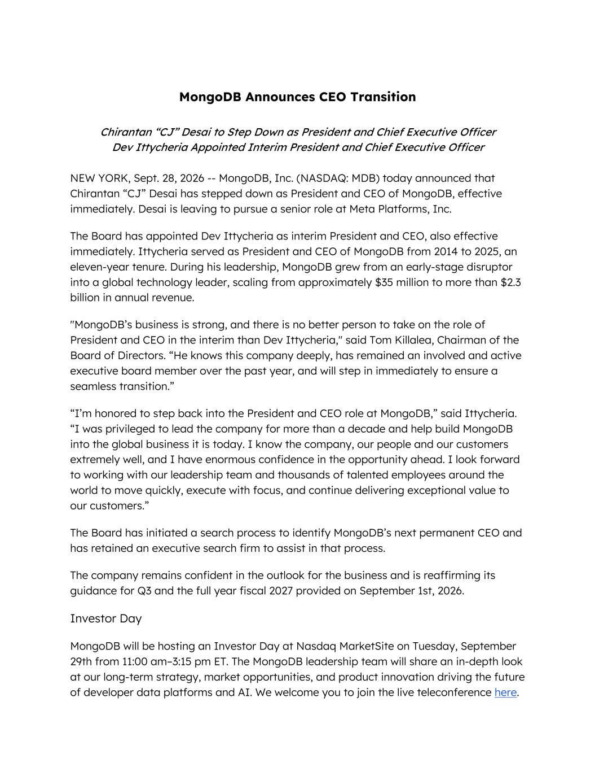

MongoDB Announces CEO Transition Chirantan “CJ” Desai to Step Down as President and Chief Executive Officer Dev Ittycheria Appointed Interim President and Chief Executive Officer NEW YORK, Sept. 28, 2026 -- MongoDB, Inc. (NASDAQ: MDB) today announced that Chirantan “CJ” Desai has stepped down as President and CEO of MongoDB, effective immediately. Desai is leaving to pursue a senior role at Meta Platforms, Inc. The Board has appointed Dev Ittycheria as interim President and CEO, also effective immediately. Ittycheria served as President and CEO of MongoDB from 2014 to 2025, an eleven-year tenure. During his leadership, MongoDB grew from an early-stage disruptor into a global technology leader, scaling from approximately $35 million to more than $2.3 billion in annual revenue. "MongoDB’s business is strong, and there is no better person to take on the role of President and CEO in the interim than Dev Ittycheria," said Tom Killalea, Chairman of the Board of Directors. “He knows this company deeply, has remained an involved and active executive board member over the past year, and will step in immediately to ensure a seamless transition.” “I’m honored to step back into the President and CEO role at MongoDB,” said Ittycheria. “I was privileged to lead the company for more than a decade and help build MongoDB into the global business it is today. I know the company, our people and our customers extremely well, and I have enormous confidence in the opportunity ahead. I look forward to working with our leadership team and thousands of talented employees around the world to move quickly, execute with focus, and continue delivering exceptional value to our customers.” The Board has initiated a search process to identify MongoDB’s next permanent CEO and has retained an executive search firm to assist in that process. The company remains confident in the outlook for the business and is reaffirming its guidance for Q3 and the full year fiscal 2027 provided on September 1st, 2026. Investor Day MongoDB will be hosting an Investor Day at Nasdaq MarketSite on Tuesday, September 29th from 11:00 am–3:15 pm ET. The MongoDB leadership team will share an in-depth look at our long-term strategy, market opportunities, and product innovation driving the future of developer data platforms and AI. We welcome you to join the live teleconference here.

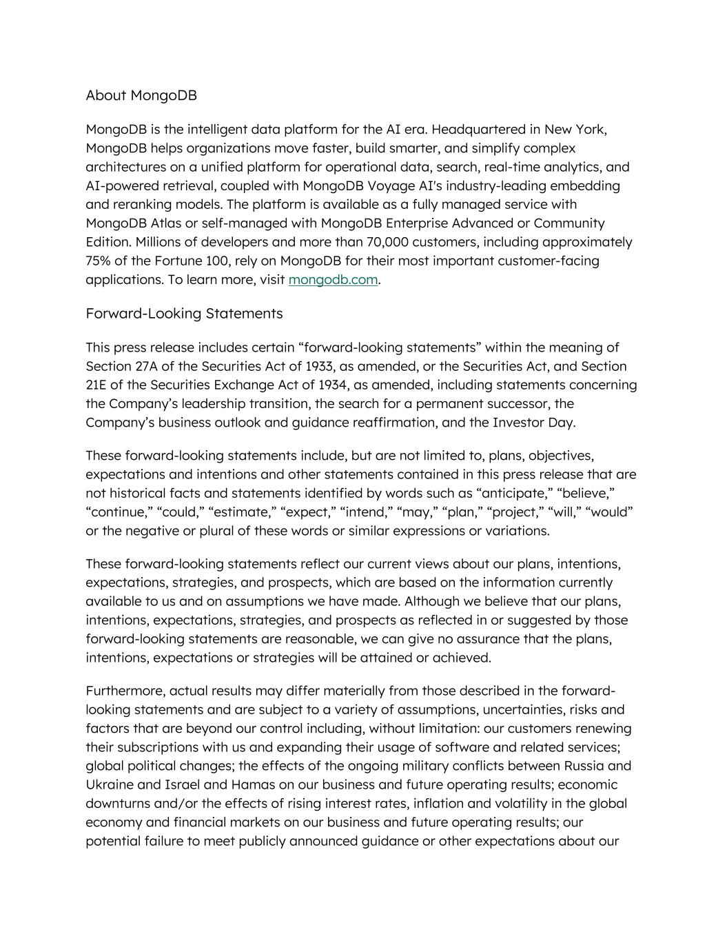
About MongoDB MongoDB is the intelligent data platform for the AI era. Headquartered in New York, MongoDB helps organizations move faster, build smarter, and simplify complex architectures on a unified platform for operational data, search, real-time analytics, and AI-powered retrieval, coupled with MongoDB Voyage AI's industry-leading embedding and reranking models. The platform is available as a fully managed service with MongoDB Atlas or self-managed with MongoDB Enterprise Advanced or Community Edition. Millions of developers and more than 70,000 customers, including approximately 75% of the Fortune 100, rely on MongoDB for their most important customer-facing applications. To learn more, visit mongodb.com. Forward-Looking Statements This press release includes certain “forward-looking statements” within the meaning of Section 27A of the Securities Act of 1933, as amended, or the Securities Act, and Section 21E of the Securities Exchange Act of 1934, as amended, including statements concerning the Company’s leadership transition, the search for a permanent successor, the Company’s business outlook and guidance reaffirmation, and the Investor Day. These forward-looking statements include, but are not limited to, plans, objectives, expectations and intentions and other statements contained in this press release that are not historical facts and statements identified by words such as “anticipate,” “believe,” “continue,” “could,” “estimate,” “expect,” “intend,” “may,” “plan,” “project,” “will,” “would” or the negative or plural of these words or similar expressions or variations. These forward-looking statements reflect our current views about our plans, intentions, expectations, strategies, and prospects, which are based on the information currently available to us and on assumptions we have made. Although we believe that our plans, intentions, expectations, strategies, and prospects as reflected in or suggested by those forward-looking statements are reasonable, we can give no assurance that the plans, intentions, expectations or strategies will be attained or achieved. Furthermore, actual results may differ materially from those described in the forward- looking statements and are subject to a variety of assumptions, uncertainties, risks and factors that are beyond our control including, without limitation: our customers renewing their subscriptions with us and expanding their usage of software and related services; global political changes; the effects of the ongoing military conflicts between Russia and Ukraine and Israel and Hamas on our business and future operating results; economic downturns and/or the effects of rising interest rates, inflation and volatility in the global economy and financial markets on our business and future operating results; our potential failure to meet publicly announced guidance or other expectations about our

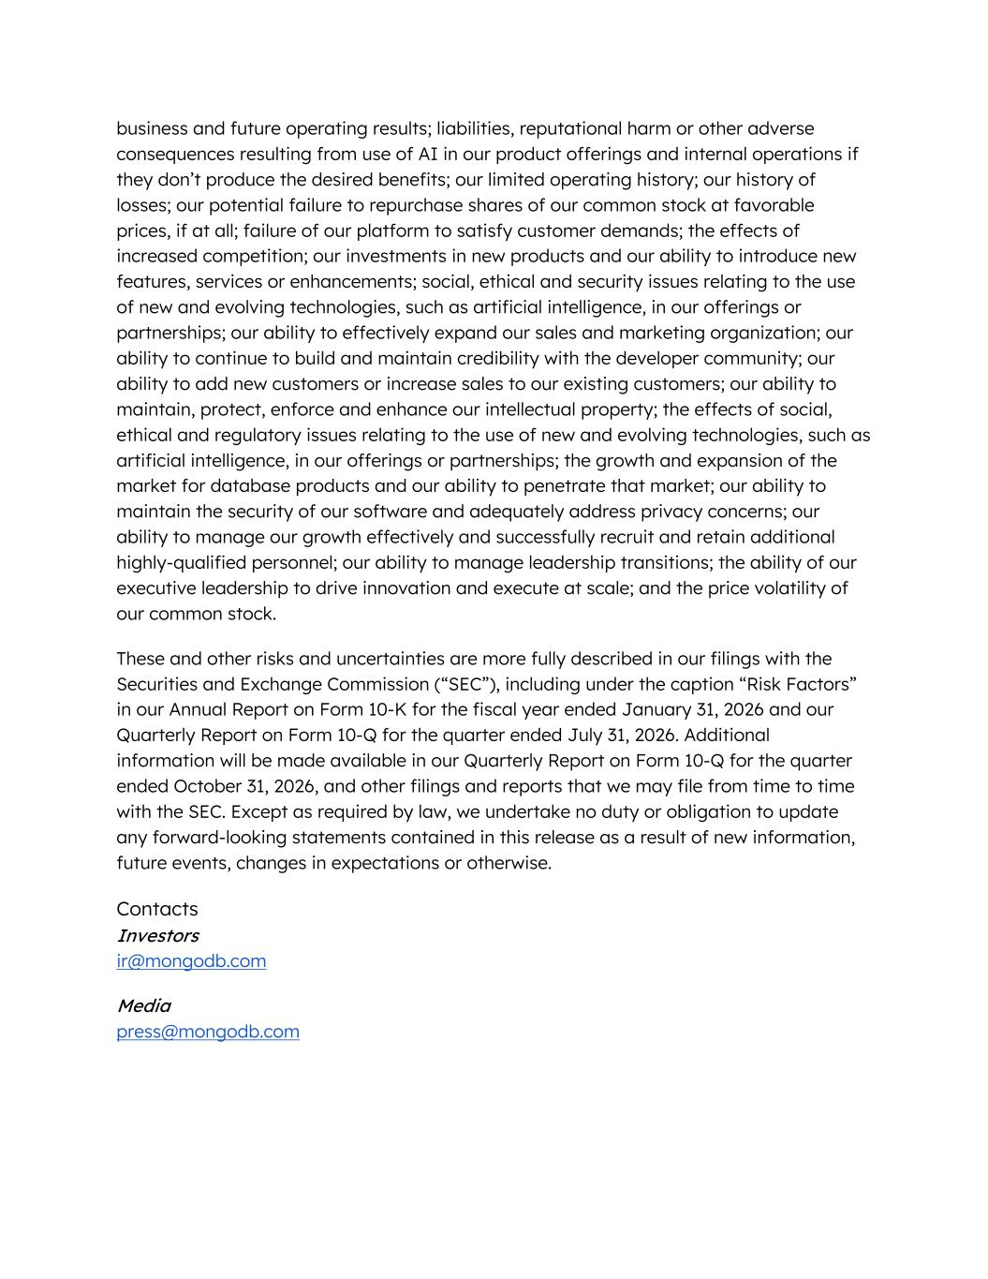
business and future operating results; liabilities, reputational harm or other adverse consequences resulting from use of AI in our product offerings and internal operations if they don’t produce the desired benefits; our limited operating history; our history of losses; our potential failure to repurchase shares of our common stock at favorable prices, if at all; failure of our platform to satisfy customer demands; the effects of increased competition; our investments in new products and our ability to introduce new features, services or enhancements; social, ethical and security issues relating to the use of new and evolving technologies, such as artificial intelligence, in our offerings or partnerships; our ability to effectively expand our sales and marketing organization; our ability to continue to build and maintain credibility with the developer community; our ability to add new customers or increase sales to our existing customers; our ability to maintain, protect, enforce and enhance our intellectual property; the effects of social, ethical and regulatory issues relating to the use of new and evolving technologies, such as artificial intelligence, in our offerings or partnerships; the growth and expansion of the market for database products and our ability to penetrate that market; our ability to maintain the security of our software and adequately address privacy concerns; our ability to manage our growth effectively and successfully recruit and retain additional highly-qualified personnel; our ability to manage leadership transitions; the ability of our executive leadership to drive innovation and execute at scale; and the price volatility of our common stock. These and other risks and uncertainties are more fully described in our filings with the Securities and Exchange Commission (“SEC”), including under the caption “Risk Factors” in our Annual Report on Form 10-K for the fiscal year ended January 31, 2026 and our Quarterly Report on Form 10-Q for the quarter ended July 31, 2026. Additional information will be made available in our Quarterly Report on Form 10-Q for the quarter ended October 31, 2026, and other filings and reports that we may file from time to time with the SEC. Except as required by law, we undertake no duty or obligation to update any forward-looking statements contained in this release as a result of new information, future events, changes in expectations or otherwise. Contacts Investors ir@mongodb.com Media press@mongodb.com

