UNITED STATES
SECURITIES AND EXCHANGE COMMISSION
WASHINGTON, D.C. 20549
___________________
FORM 8-K
___________________
CURRENT REPORT
Pursuant to Section 13 or 15(d) of the Securities Exchange Act of 1934
Date of Report (Date of earliest event reported): June 30, 2026
___________________
MONGODB, INC.
(Exact Name of Registrant as Specified in its Charter)
___________________
Delaware |  |  |  |  |  | 001-38240 |  |  | 26-1463205
(State or Other Jurisdiction  of Incorporation) |  |  |  |  |  | (Commission File Number) |  |  | (IRS Employer  Identification No.)
1633 Broadway, |  |  | 38th Floor
New York, |  |  | NY |  |  |  |  |  | 10019
(Address of Principal Executive Offices) |  |  |  |  |  |  |  |  | (Zip Code)
646-727-4092
(Registrant’s Telephone Number, Including Area Code)
Not Applicable
(Former Name or Former Address, if Changed Since Last Report)
___________________
Check the appropriate box below if the Form 8-K filing is intended to simultaneously satisfy the filing obligation of the registrant under any of the following provisions (see General Instructions A.2. below):
☐ Written communications pursuant to Rule 425 under the Securities Act (17 CFR 230.425)
☐ Soliciting material pursuant to Rule 14a-12 under the Exchange Act (17 CFR 240.14a-12)
☐ Pre-commencement communications pursuant to Rule 14d-2(b) under the Exchange Act (17 CFR 240.14d-2(b))
☐ Pre-commencement communications pursuant to Rule 13e-4(c) under the Exchange Act (17 CFR 240.13e-4(c))
Securities registered pursuant to Section 12(b) of the Exchange Act:
Title of each class |  |  |  |  |  | Trading Symbol(s) |  |  |  |  |  | Name of each exchange on which registered
Common Stock, par value $0.001 per share |  |  |  |  |  | MDB |  |  |  |  |  | The Nasdaq Stock Market LLC
 |  |  |  |  |  |  |  |  |  |  |  | (Nasdaq Global Market)
Indicate by check mark whether the registrant is an emerging growth company as defined in Rule 405 of the Securities Act of 1933 (§230.405 of this chapter) or Rule 12b-2 of the Securities Exchange Act of 1934 (§240.12b-2 of this chapter).
Emerging growth company ☐
If an emerging growth company, indicate by check mark if the registrant has elected not to use the extended transition period for complying with any new or revised financial accounting standards provided pursuant to Section 13(a) of the Exchange Act. ☐

Item 5.03 Amendments to Articles of Incorporation or Bylaws; Change in Fiscal Year.
On June 30, 2026, MongoDB, Inc. (the “Company”) held its Annual Meeting of Stockholders (the “Annual Meeting”), at which stockholders approved amendments to the Company's Amended and Restated Certificate of Incorporation (the "Existing Charter") to eliminate supermajority vote requirements (the "Supermajority Removal Amendment"). A summary of the Supermajority Removal Amendment was included in Proposal 4 in the Company's definitive proxy statement filed with the Securities and Exchange Commission (the "SEC") on May 19, 2026 and the supplement to the definitive proxy statement, filed with the SEC on June 1, 2026 (together, the "Proxy Statement"), which summary is incorporated herein by reference and is qualified in its entirety by reference to the full text of the new Twelfth Amended and Restated Certificate of Incorporation filed herewith as Exhibit 3.1 (the "Amended and Restated Charter").
The Amended and Restated Charter of the Company was filed with the Secretary of State of the State of Delaware on July 1, 2026 and became effective on July 1, 2026.
Item 5.07 Submission of Matters to a Vote of Security Holders.
On June 30, 2026, the Company held its Annual Meeting. At the Annual Meeting, the Company’s stockholders voted on the four proposals set forth below. A more detailed description of each proposal is set forth in the Company’s Proxy Statement.
Proposal 1 – Election of Directors.
Each of Archana Agrawal, Hope Cochran and Dwight Merriman was elected to serve as a Class III director of the Company’s Board of Directors until the 2029 Annual Meeting of Stockholders and until his or her successor has been duly elected, or if sooner, until the director’s death, resignation or removal, by the following votes:
Nominee |  |  |  |  |  | Votes For |  |  |  |  |  | Votes Withheld |  |  |  |  |  | Broker Non-Votes
Archana Agrawal |  |  |  |  |  | 46,240,992 |  |  |  |  |  | 12,616,760 |  |  |  |  |  | 9,262,190
Hope Cochran |  |  |  |  |  | 42,656,764 |  |  |  |  |  | 16,200,988 |  |  |  |  |  | 9,262,190
Dwight Merriman |  |  |  |  |  | 47,316,152 |  |  |  |  |  | 11,541,600 |  |  |  |  |  | 9,262,190
Proposal 2 – Approval, on a non-binding advisory basis, of the compensation of the Company’s named executive officers.
The stockholders approved, on a non-binding advisory basis, the compensation of the Company’s named executive officers, by the following votes:
Votes For |  |  |  |  |  | Votes Against |  |  |  |  |  | Abstentions |  |  |  |  |  | Broker Non-Votes
52,364,797 |  |  |  |  |  | 6,338,858 |  |  |  |  |  | 154,097 |  |  |  |  |  | 9,262,190
Proposal 3 – Ratification of the selection of Independent Registered Public Accounting Firm.
The stockholders ratified the selection of PricewaterhouseCoopers LLP as the Company’s independent registered public accounting firm for the Company’s fiscal year ending January 31, 2027, by the following votes:
Votes For |  |  |  |  |  | Votes Against |  |  |  |  |  | Abstentions |  |  | Broker Non-Votes
65,331,456 |  |  |  |  |  | 2,754,179 |  |  |  |  |  | 34,307 |  |  | —

Proposal 4 – Approval of an amendment to the Company's Existing Charter to eliminate supermajority vote requirements.
The stockholders approved an amendment to the Company’s Existing Charter to eliminate supermajority vote requirements, by the following votes:
Votes For |  |  |  |  |  | Votes Against |  |  |  |  |  | Abstentions |  |  |  |  |  | Broker Non-Votes
58,762,935 |  |  |  |  |  | 68,287 |  |  |  |  |  | 26,530 |  |  |  |  |  | 9,262,190

Item 9.01 Financial Statements and Exhibits.
(d) Exhibits
Exhibit No. |  |  | Description
3.1 |  |  | Twelfth Amended and Restated Certificate of Incorporation of MongoDB, Inc.
104 |  |  | Cover Page Interactive Data File (embedded within the Inline XBRL document)

SIGNATURES
Pursuant to the requirements of the Securities Exchange Act of 1934, as amended, the Registrant has duly caused this report to be signed on its behalf by the undersigned hereunto duly authorized.
 |  |  | MONGODB, INC.
Dated: July 6, 2026 |  |  | By: |  |  |  |  |  | /s/ Andrew Stephens
Name: Andrew Stephens
Title: Chief Legal Officer and Secretary

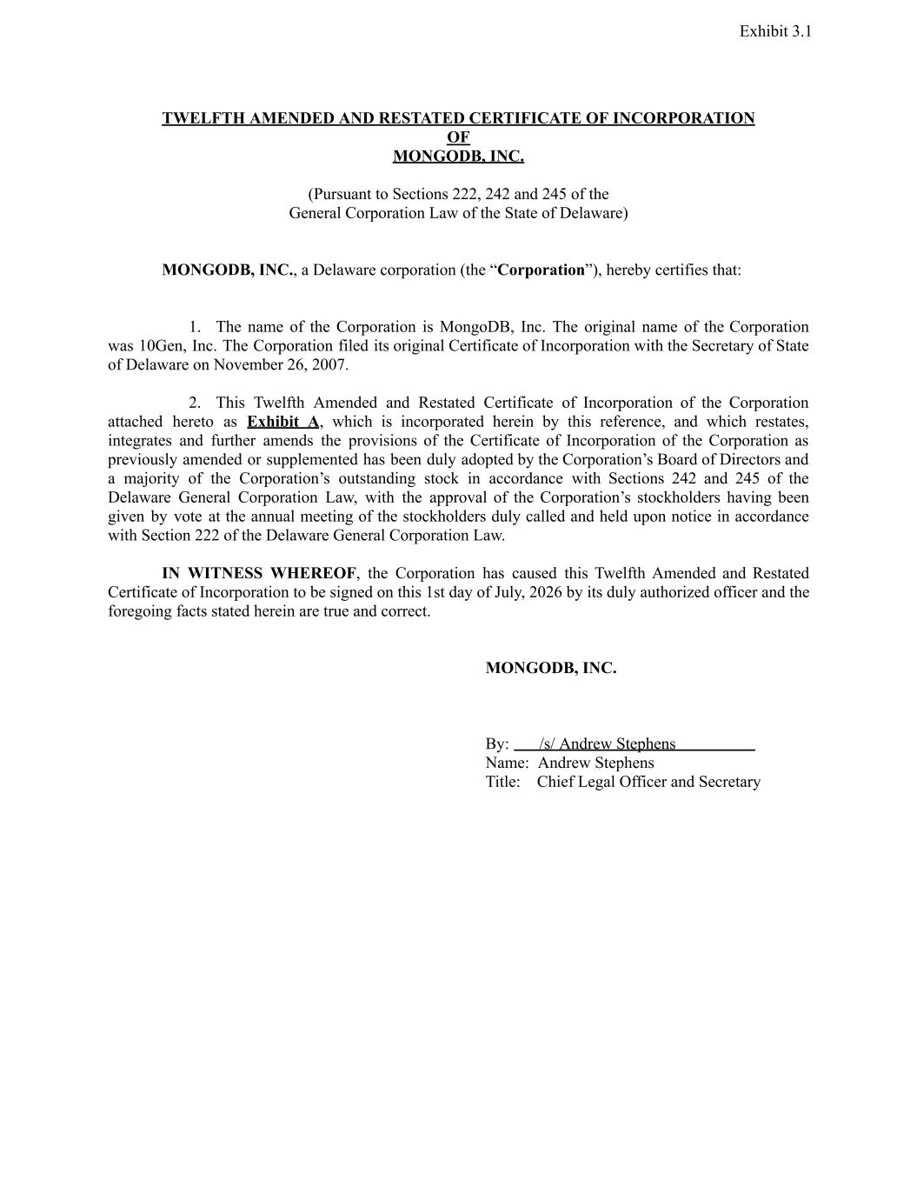

TWELFTH AMENDED AND RESTATED CERTIFICATE OF INCORPORATION OF MONGODB, INC. (Pursuant to Sections 222, 242 and 245 of the General Corporation Law of the State of Delaware) MONGODB, INC., a Delaware corporation (the “Corporation”), hereby certifies that: 1. The name of the Corporation is MongoDB, Inc. The original name of the Corporation was 10Gen, Inc. The Corporation filed its original Certificate of Incorporation with the Secretary of State of Delaware on November 26, 2007. 2. This Twelfth Amended and Restated Certificate of Incorporation of the Corporation attached hereto as Exhibit A, which is incorporated herein by this reference, and which restates, integrates and further amends the provisions of the Certificate of Incorporation of the Corporation as previously amended or supplemented has been duly adopted by the Corporation’s Board of Directors and a majority of the Corporation’s outstanding stock in accordance with Sections 242 and 245 of the Delaware General Corporation Law, with the approval of the Corporation’s stockholders having been given by vote at the annual meeting of the stockholders duly called and held upon notice in accordance with Section 222 of the Delaware General Corporation Law. IN WITNESS WHEREOF, the Corporation has caused this Twelfth Amended and Restated Certificate of Incorporation to be signed on this 1st day of July, 2026 by its duly authorized officer and the foregoing facts stated herein are true and correct. MONGODB, INC. By: ​ /s/ Andrew Stephens​ ​ Name: Andrew Stephens Title: Chief Legal Officer and Secretary Exhibit 3.1

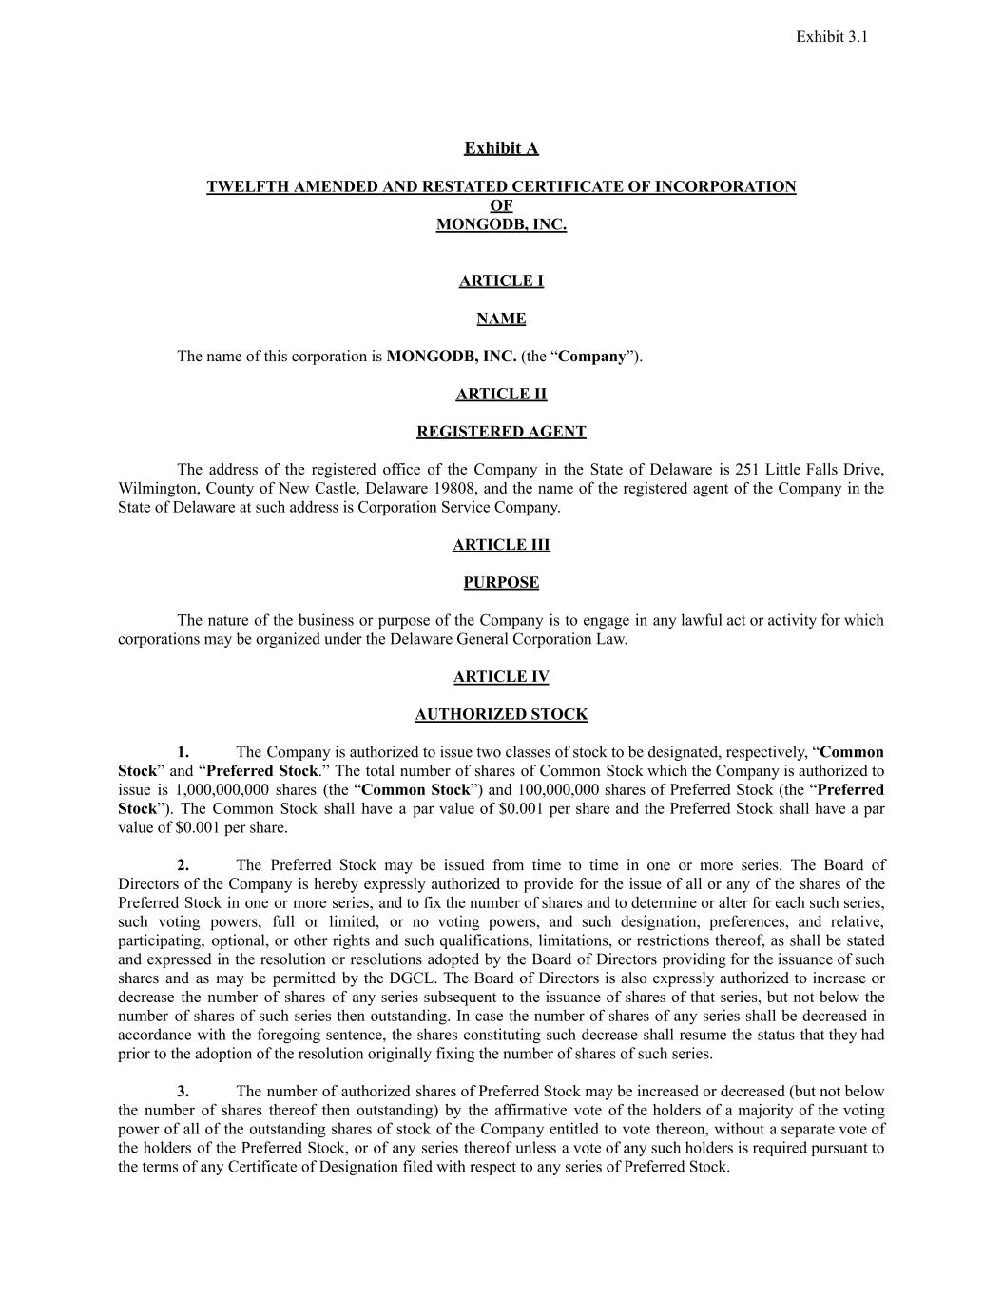
Exhibit A TWELFTH AMENDED AND RESTATED CERTIFICATE OF INCORPORATION​ OF​ MONGODB, INC. ARTICLE I NAME The name of this corporation is MONGODB, INC. (the “Company”). ARTICLE II REGISTERED AGENT The address of the registered office of the Company in the State of Delaware is 251 Little Falls Drive, Wilmington, County of New Castle, Delaware 19808, and the name of the registered agent of the Company in the State of Delaware at such address is Corporation Service Company. ARTICLE III PURPOSE The nature of the business or purpose of the Company is to engage in any lawful act or activity for which corporations may be organized under the Delaware General Corporation Law. ARTICLE IV AUTHORIZED STOCK 1. The Company is authorized to issue two classes of stock to be designated, respectively, “Common Stock” and “Preferred Stock.” The total number of shares of Common Stock which the Company is authorized to issue is 1,000,000,000 shares (the “Common Stock”) and 100,000,000 shares of Preferred Stock (the “Preferred Stock”). The Common Stock shall have a par value of $0.001 per share and the Preferred Stock shall have a par value of $0.001 per share. 2. The Preferred Stock may be issued from time to time in one or more series. The Board of Directors of the Company is hereby expressly authorized to provide for the issue of all or any of the shares of the Preferred Stock in one or more series, and to fix the number of shares and to determine or alter for each such series, such voting powers, full or limited, or no voting powers, and such designation, preferences, and relative, participating, optional, or other rights and such qualifications, limitations, or restrictions thereof, as shall be stated and expressed in the resolution or resolutions adopted by the Board of Directors providing for the issuance of such shares and as may be permitted by the DGCL. The Board of Directors is also expressly authorized to increase or decrease the number of shares of any series subsequent to the issuance of shares of that series, but not below the number of shares of such series then outstanding. In case the number of shares of any series shall be decreased in accordance with the foregoing sentence, the shares constituting such decrease shall resume the status that they had prior to the adoption of the resolution originally fixing the number of shares of such series. 3. The number of authorized shares of Preferred Stock may be increased or decreased (but not below the number of shares thereof then outstanding) by the affirmative vote of the holders of a majority of the voting power of all of the outstanding shares of stock of the Company entitled to vote thereon, without a separate vote of the holders of the Preferred Stock, or of any series thereof unless a vote of any such holders is required pursuant to the terms of any Certificate of Designation filed with respect to any series of Preferred Stock. Exhibit 3.1

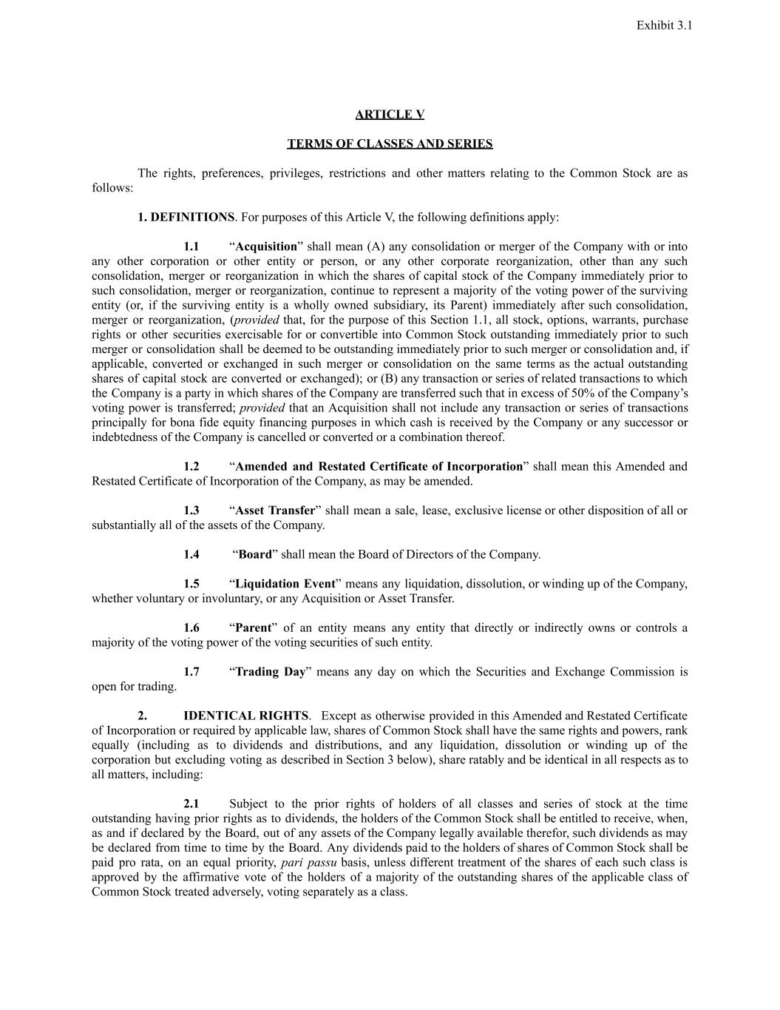
ARTICLE V TERMS OF CLASSES AND SERIES The rights, preferences, privileges, restrictions and other matters relating to the Common Stock are as follows: 1. DEFINITIONS. For purposes of this Article V, the following definitions apply: 1.1 ​ “Acquisition” shall mean (A) any consolidation or merger of the Company with or into any other corporation or other entity or person, or any other corporate reorganization, other than any such consolidation, merger or reorganization in which the shares of capital stock of the Company immediately prior to such consolidation, merger or reorganization, continue to represent a majority of the voting power of the surviving entity (or, if the surviving entity is a wholly owned subsidiary, its Parent) immediately after such consolidation, merger or reorganization, (provided that, for the purpose of this Section 1.1, all stock, options, warrants, purchase rights or other securities exercisable for or convertible into Common Stock outstanding immediately prior to such merger or consolidation shall be deemed to be outstanding immediately prior to such merger or consolidation and, if applicable, converted or exchanged in such merger or consolidation on the same terms as the actual outstanding shares of capital stock are converted or exchanged); or (B) any transaction or series of related transactions to which the Company is a party in which shares of the Company are transferred such that in excess of 50% of the Company’s voting power is transferred; provided that an Acquisition shall not include any transaction or series of transactions principally for bona fide equity financing purposes in which cash is received by the Company or any successor or indebtedness of the Company is cancelled or converted or a combination thereof. 1.2 “Amended and Restated Certificate of Incorporation” shall mean this Amended and Restated Certificate of Incorporation of the Company, as may be amended. 1.3 “Asset Transfer” shall mean a sale, lease, exclusive license or other disposition of all or substantially all of the assets of the Company. 1.4​ “Board” shall mean the Board of Directors of the Company. 1.5 “Liquidation Event” means any liquidation, dissolution, or winding up of the Company, whether voluntary or involuntary, or any Acquisition or Asset Transfer. 1.6 “Parent” of an entity means any entity that directly or indirectly owns or controls a majority of the voting power of the voting securities of such entity. 1.7 “Trading Day” means any day on which the Securities and Exchange Commission is open for trading. 2. IDENTICAL RIGHTS. ​ Except as otherwise provided in this Amended and Restated Certificate of Incorporation or required by applicable law, shares of Common Stock shall have the same rights and powers, rank equally (including as to dividends and distributions, and any liquidation, dissolution or winding up of the corporation but excluding voting as described in Section 3 below), share ratably and be identical in all respects as to all matters, including: 2.1 ​ Subject to the prior rights of holders of all classes and series of stock at the time outstanding having prior rights as to dividends, the holders of the Common Stock shall be entitled to receive, when, as and if declared by the Board, out of any assets of the Company legally available therefor, such dividends as may be declared from time to time by the Board. Any dividends paid to the holders of shares of Common Stock shall be paid pro rata, on an equal priority, pari passu basis, unless different treatment of the shares of each such class is approved by the affirmative vote of the holders of a majority of the outstanding shares of the applicable class of Common Stock treated adversely, voting separately as a class. Exhibit 3.1

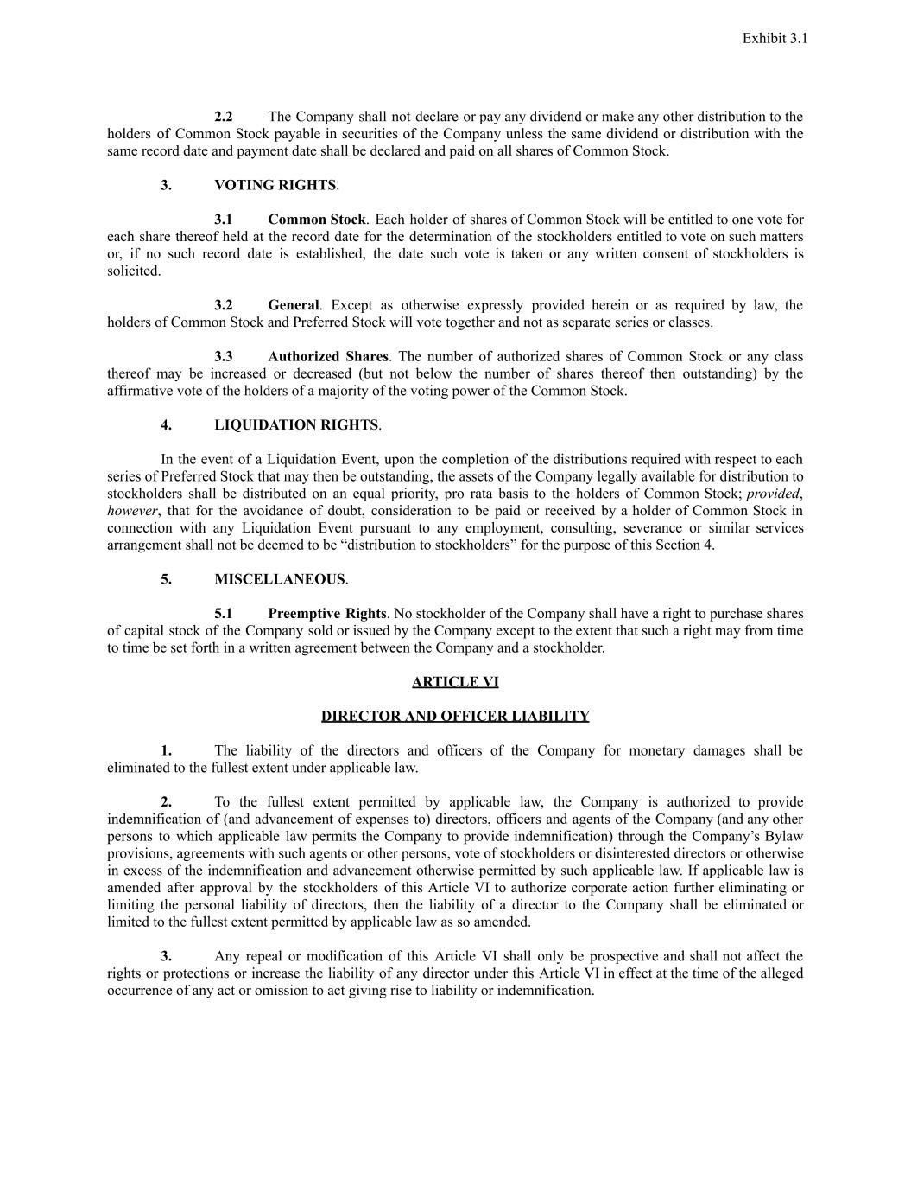
2.2 ​ The Company shall not declare or pay any dividend or make any other distribution to the holders of Common Stock payable in securities of the Company unless the same dividend or distribution with the same record date and payment date shall be declared and paid on all shares of Common Stock. 3. VOTING RIGHTS. 3.1 Common Stock. ​Each holder of shares of Common Stock will be entitled to one vote for each share thereof held at the record date for the determination of the stockholders entitled to vote on such matters or, if no such record date is established, the date such vote is taken or any written consent of stockholders is solicited. 3.2 General. Except as otherwise expressly provided herein or as required by law, the holders of Common Stock and Preferred Stock will vote together and not as separate series or classes. 3.3 ​ Authorized Shares. The number of authorized shares of Common Stock or any class thereof may be increased or decreased (but not below the number of shares thereof then outstanding) by the affirmative vote of the holders of a majority of the voting power of the Common Stock. 4. LIQUIDATION RIGHTS. In the event of a Liquidation Event, upon the completion of the distributions required with respect to each series of Preferred Stock that may then be outstanding, the assets of the Company legally available for distribution to stockholders shall be distributed on an equal priority, pro rata basis to the holders of Common Stock; provided, however, that for the avoidance of doubt, consideration to be paid or received by a holder of Common Stock in connection with any Liquidation Event pursuant to any employment, consulting, severance or similar services arrangement shall not be deemed to be “distribution to stockholders” for the purpose of this Section 4. 5. MISCELLANEOUS. 5.1 Preemptive Rights. No stockholder of the Company shall have a right to purchase shares of capital stock of the Company sold or issued by the Company except to the extent that such a right may from time to time be set forth in a written agreement between the Company and a stockholder. ARTICLE VI DIRECTOR AND OFFICER LIABILITY 1. The liability of the directors and officers of the Company for monetary damages shall be eliminated to the fullest extent under applicable law. 2. To the fullest extent permitted by applicable law, the Company is authorized to provide indemnification of (and advancement of expenses to) directors, officers and agents of the Company (and any other persons to which applicable law permits the Company to provide indemnification) through the Company’s Bylaw provisions, agreements with such agents or other persons, vote of stockholders or disinterested directors or otherwise in excess of the indemnification and advancement otherwise permitted by such applicable law. If applicable law is amended after approval by the stockholders of this Article VI to authorize corporate action further eliminating or limiting the personal liability of directors, then the liability of a director to the Company shall be eliminated or limited to the fullest extent permitted by applicable law as so amended. 3. Any repeal or modification of this Article VI shall only be prospective and shall not affect the rights or protections or increase the liability of any director under this Article VI in effect at the time of the alleged occurrence of any act or omission to act giving rise to liability or indemnification. Exhibit 3.1

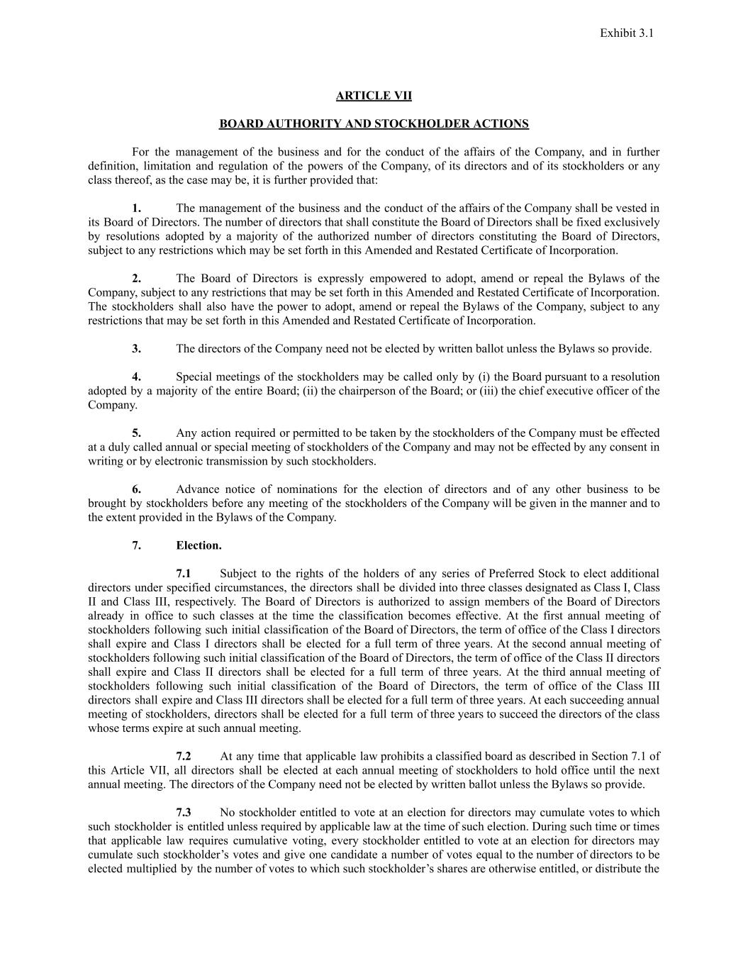
ARTICLE VII BOARD AUTHORITY AND STOCKHOLDER ACTIONS For the management of the business and for the conduct of the affairs of the Company, and in further definition, limitation and regulation of the powers of the Company, of its directors and of its stockholders or any class thereof, as the case may be, it is further provided that: 1. The management of the business and the conduct of the affairs of the Company shall be vested in its Board of Directors. The number of directors that shall constitute the Board of Directors shall be fixed exclusively by resolutions adopted by a majority of the authorized number of directors constituting the Board of Directors, subject to any restrictions which may be set forth in this Amended and Restated Certificate of Incorporation. 2. The Board of Directors is expressly empowered to adopt, amend or repeal the Bylaws of the Company, subject to any restrictions that may be set forth in this Amended and Restated Certificate of Incorporation. The stockholders shall also have the power to adopt, amend or repeal the Bylaws of the Company, subject to any restrictions that may be set forth in this Amended and Restated Certificate of Incorporation. 3. The directors of the Company need not be elected by written ballot unless the Bylaws so provide. 4. Special meetings of the stockholders may be called only by (i) the Board pursuant to a resolution adopted by a majority of the entire Board; (ii) the chairperson of the Board; or (iii) the chief executive officer of the Company. 5. Any action required or permitted to be taken by the stockholders of the Company must be effected at a duly called annual or special meeting of stockholders of the Company and may not be effected by any consent in writing or by electronic transmission by such stockholders. 6. Advance notice of nominations for the election of directors and of any other business to be brought by stockholders before any meeting of the stockholders of the Company will be given in the manner and to the extent provided in the Bylaws of the Company. 7. Election. 7.1 Subject to the rights of the holders of any series of Preferred Stock to elect additional directors under specified circumstances, the directors shall be divided into three classes designated as Class I, Class II and Class III, respectively. The Board of Directors is authorized to assign members of the Board of Directors already in office to such classes at the time the classification becomes effective. At the first annual meeting of stockholders following such initial classification of the Board of Directors, the term of office of the Class I directors shall expire and Class I directors shall be elected for a full term of three years. At the second annual meeting of stockholders following such initial classification of the Board of Directors, the term of office of the Class II directors shall expire and Class II directors shall be elected for a full term of three years. At the third annual meeting of stockholders following such initial classification of the Board of Directors, the term of office of the Class III directors shall expire and Class III directors shall be elected for a full term of three years. At each succeeding annual meeting of stockholders, directors shall be elected for a full term of three years to succeed the directors of the class whose terms expire at such annual meeting. 7.2 ​ At any time that applicable law prohibits a classified board as described in Section 7.1 of this Article VII, all directors shall be elected at each annual meeting of stockholders to hold office until the next annual meeting. The directors of the Company need not be elected by written ballot unless the Bylaws so provide. 7.3 ​ No stockholder entitled to vote at an election for directors may cumulate votes to which such stockholder is entitled unless required by applicable law at the time of such election. During such time or times that applicable law requires cumulative voting, every stockholder entitled to vote at an election for directors may cumulate such stockholder’s votes and give one candidate a number of votes equal to the number of directors to be elected multiplied by the number of votes to which such stockholder’s shares are otherwise entitled, or distribute the Exhibit 3.1

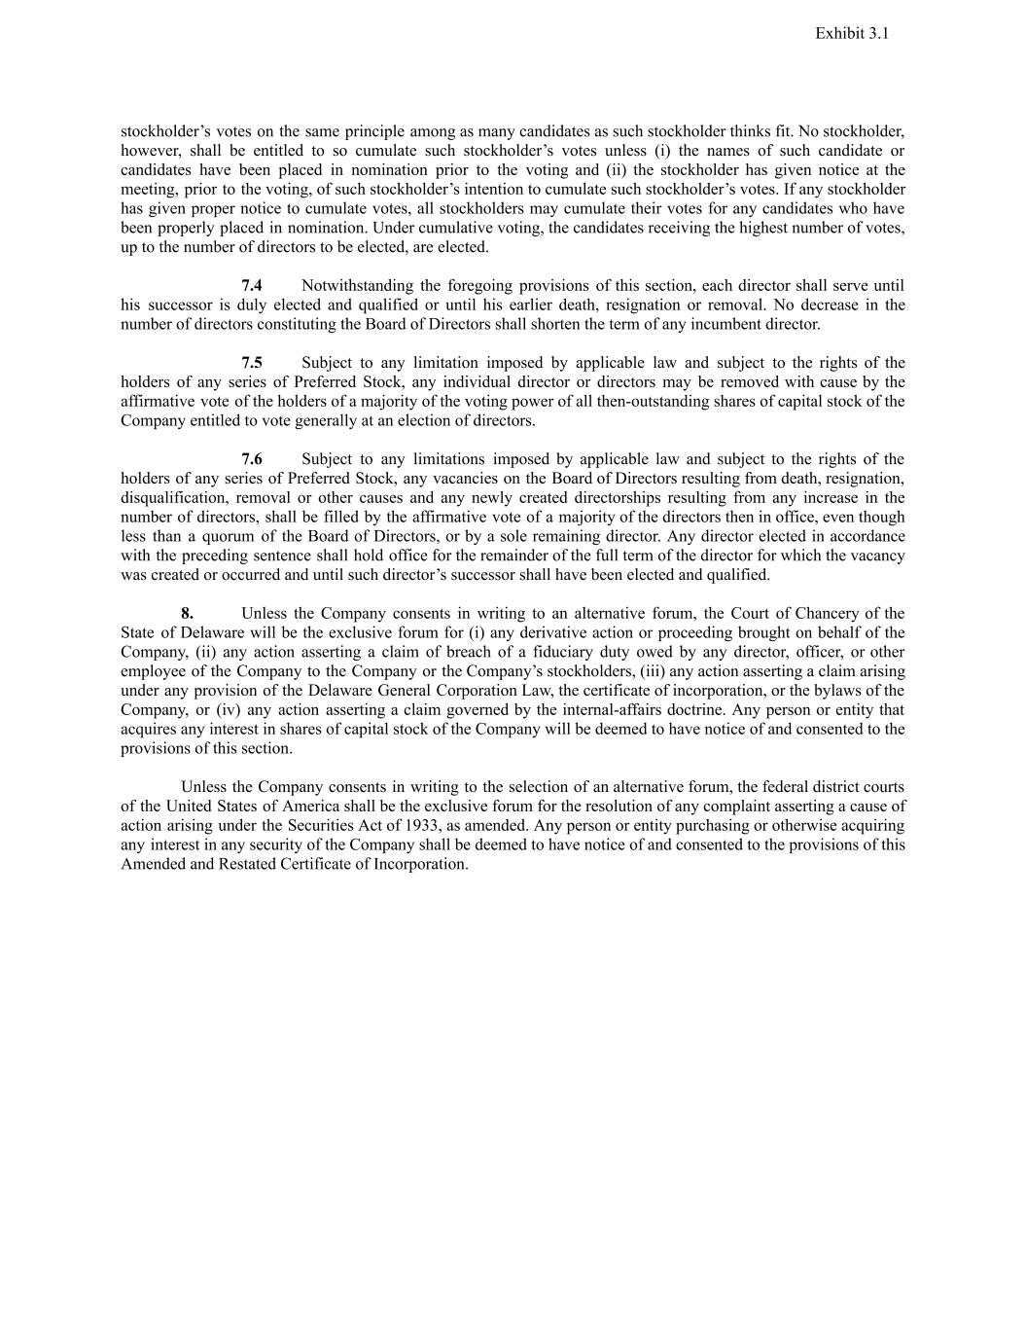
stockholder’s votes on the same principle among as many candidates as such stockholder thinks fit. No stockholder, however, shall be entitled to so cumulate such stockholder’s votes unless (i) the names of such candidate or candidates have been placed in nomination prior to the voting and (ii) the stockholder has given notice at the meeting, prior to the voting, of such stockholder’s intention to cumulate such stockholder’s votes. If any stockholder has given proper notice to cumulate votes, all stockholders may cumulate their votes for any candidates who have been properly placed in nomination. Under cumulative voting, the candidates receiving the highest number of votes, up to the number of directors to be elected, are elected. 7.4 ​ Notwithstanding the foregoing provisions of this section, each director shall serve until his successor is duly elected and qualified or until his earlier death, resignation or removal. No decrease in the number of directors constituting the Board of Directors shall shorten the term of any incumbent director. 7.5 ​ Subject to any limitation imposed by applicable law and subject to the rights of the holders of any series of Preferred Stock, any individual director or directors may be removed with cause by the affirmative vote of the holders of a majority of the voting power of all then-outstanding shares of capital stock of the Company entitled to vote generally at an election of directors. 7.6 ​ Subject to any limitations imposed by applicable law and subject to the rights of the holders of any series of Preferred Stock, any vacancies on the Board of Directors resulting from death, resignation, disqualification, removal or other causes and any newly created directorships resulting from any increase in the number of directors, shall be filled by the affirmative vote of a majority of the directors then in office, even though less than a quorum of the Board of Directors, or by a sole remaining director. Any director elected in accordance with the preceding sentence shall hold office for the remainder of the full term of the director for which the vacancy was created or occurred and until such director’s successor shall have been elected and qualified. 8. Unless the Company consents in writing to an alternative forum, the Court of Chancery of the State of Delaware will be the exclusive forum for (i) any derivative action or proceeding brought on behalf of the Company, (ii) any action asserting a claim of breach of a fiduciary duty owed by any director, officer, or other employee of the Company to the Company or the Company’s stockholders, (iii) any action asserting a claim arising under any provision of the Delaware General Corporation Law, the certificate of incorporation, or the bylaws of the Company, or (iv) any action asserting a claim governed by the internal-affairs doctrine. Any person or entity that acquires any interest in shares of capital stock of the Company will be deemed to have notice of and consented to the provisions of this section. Unless the Company consents in writing to the selection of an alternative forum, the federal district courts of the United States of America shall be the exclusive forum for the resolution of any complaint asserting a cause of action arising under the Securities Act of 1933, as amended. Any person or entity purchasing or otherwise acquiring any interest in any security of the Company shall be deemed to have notice of and consented to the provisions of this Amended and Restated Certificate of Incorporation. Exhibit 3.1

